Conclusion
In this analysis “Normal Model” is the model with both conjugation and R(a), (R(a) being the response function to slow down run speed in antibiotic). Significant differences are found when comparing the Mann-Whitney U effect sizes of the Normal Model to the others. Compared to the groups without conjugation both with and without R(a), the effect size differs by -2.979 and -2.782 (p < 0.01), support that the conjugation equation provides a statistically significant time difference for fixation. The effect size of Normal Model compared to the model with conjugation but no R(a) was 3.461 (p < 0.001), indicating that this was the most statistically significant difference. The differences of the distribution are visible in the boxenplot of figure 1. The medians for Normal Model, No Conj, No R_a with Conj, and No R_a No Conj were 4316s, 4918s, 3323s, and 4938s.
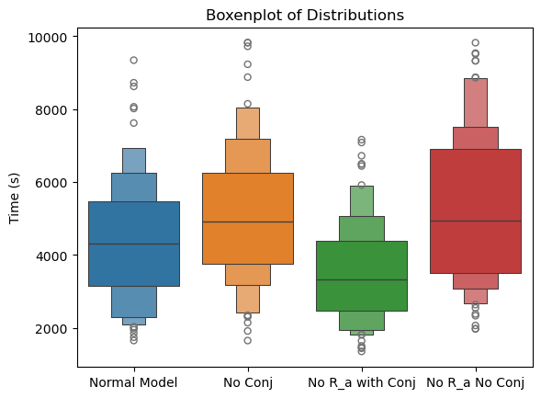
Figure 1 – Boxenplot of Time (s) Distributions until mutant fixation in antibiotic.
Another Mann-Whitney U test was performed between the two models without conjugation which showed that the presence or absence of R(a) had no statistically significant effect. A permutation test was performed under the assumption of null hypothesis that there is no statistical difference between the means of conjugation being present, (Mean difference when Conjugation is present - Mean difference when Conjugation is absent), with an observed interaction of 955.36s (p = 0.01). This further emphasizes the time difference of R(a) present and absent is larger when Conjugation is absent than when it is present. The statistical differences of R(a) and conjugation can be seen in figure 2.

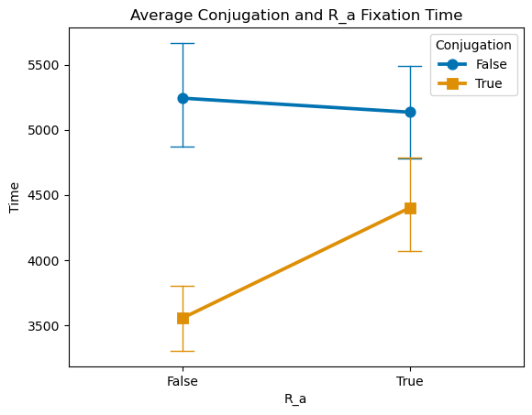
Figure 2 – Pointplot of Conjugation (T/F) and R(a) (T/F) Fixation Time (s)
The relationship was investigated further using regression analysis. The model analyzed the variables no R(a) and Conjugation against log(Time) including No_R_a*Conjugation. It confirmed that the absence of R(a) itself has no statistically significant impact on reducing time $β=+ 0.0093 (p=0.87)$. The model with the best fit had an R-squared of 13.5% and investigated the combined effect of conjugation and no R(a), (No_R_a_Conj), and Conjugation. Conjugation had a significant impact at reducing log(time), $β=-0.1713 (p=0.001)$, while the interaction with R(a) had a further significant impact on reducing time, $β=-0.2125 (p<0.0001)$. This presents evidence that the synergistic relationship provides a greater statistically significant advantage for reducing time to fix into a population compared to conjugation itself, while R(a) did not provide any significant advantage on it’s own.

The next variable measured to analyze time to fixation was chemotaxis, whereby the model with “Chemotaxis” was compared to a model with just random diffusion, (“Diffusion”). A Mann-Whitney U test on the skewed time distributions showed a statistically significant difference between the two distributions, with the median of Chemotaxis and Diffusion being 16801 s and 19818 s, (p < 0.0001). Regression analysis of chemotaxis on log(time) shows a significant coefficient to reduce log(time) to fixation, $β=-0.1735 (p<0.0001)$. The R-squared explained 56.3% of the variability and the F-statistic was highly significant (240.8) indicating that chemotaxis has a better fit than the first model. Even the coefficient is lower than No_R_a_Conj, the higher R-squared means chemotaxis accounts for a larger portion of the variability and plays a larger role for reducing time to fixation.
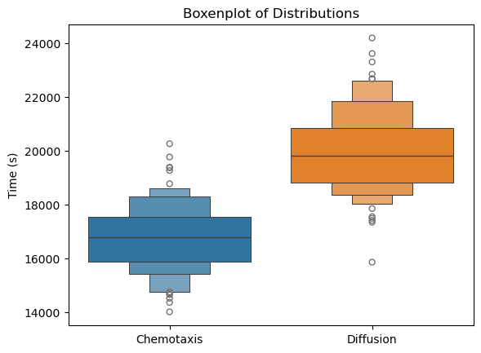
Figure 3 – Boxenplot of Time Distributions until mutant fixation in antibiotic for Chemotaxis vs Diffusion.

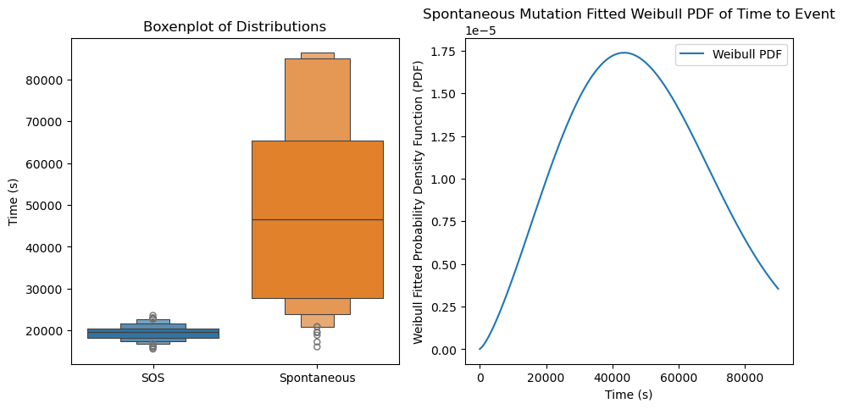
Figure 4 – [Left] Boxenplot of Time (s) Distributions until mutant fixation in antibiotic for SOS vs Spontaneous mutation rate. [Right] Spontaneous Mutation Fitted Weibull PDF Parameters: Shape (k) = 2.97, indicating that the event becomes more likely as time goes on, Scale (λ) = 69444.47 s (19.29 h), Median (50th percentile) = 61379.63 s (17.05 h).
The next variable analyzed was the SOS mutation rate of bacteria. The mutation rate follows a Poisson distribution and in this model was 100 times faster than the “Spontaneous”, (non-SOS), mutation rate in antibiotic regions under duress. Data collection had a cutoff of 24h (86400 seconds), and so a Weibull distribution was required to estimate the ‘Time’ that exceeded cutoff during Spontaneous mutation data collection using the mean: $λΓ\left(1+ 1/k\right)$. The parameters were $k=2.34$, (k > 1 indicates that the event becomes more likely as time goes on), and $λ=\sqrt{2}σ=55211.32 s$, with an estimated median time of $47213.37 s (13.11 hr)$, compared to the median time of SOS being $19558.50 s (5.43 h)$. Regression analysis shows the SOS reducing log(time) by $β=-0.7330 (p < 0.0001)$, while the R-squared explained 58.7% of the variability. This combined with F-statistic (278.2) indicated the strongest fit. The findings indicate that the SOS response is the most significant factor for bacterial adaptation and survival in the model. This stochastic factor is the cause of the high variability while analyzing the other variables.

Parameter | Coefficient | Std. Error | z | P>|z| | [0.025 | 0.975]
Intercept | 10.523 | 0.571 | 18.424 | 0 | 9.403 | 11.642
Chemotaxis[T.True] | -0.174 | 0.047 | -3.685 | 0 | -0.267 | -0.081
Conjugation[T.True] | -0.171 | 0.04 | -4.24 | 0 | -0.251 | -0.092
No_R_a_Conj[T.True] | -0.211 | 0.046 | -4.554 | 0 | -0.302 | -0.12
SOS[T.True] | -0.734 | 0.046 | -15.902 | 0 | -0.824 | -0.643
Dataset Var | 0.966 | 2.996

Table 1 - Final Mixed-Effect Regression Model

All variables in the table significantly reduce the time until mutant bacteria fix into a population along an antibiotic gradient $(p<0.001)$. The variance between datasets accounts for a change in bacterial starting positions along the gradient. The variables R_a with Conjugation is the least consequential in reducing time to fixation due to the R-squared value, but the combined coefficients are the largest ($β=-0.171),(β =-0.211)$. The cause of this is due to a greater population of bacteria in a region of antibiotic, thereby making mutation more frequent. This increase in genetic diversity when combined with a high enough conjugation rate will help to increase the speed at which a mutant will fix in a population. This synergistic relationship could be explored further for optimizing bacterial fixation strategies with a more advanced conjugation and plasmid model. Chemotaxis provides a more consequential time to fixation due to the model’s R-squared having a greater fit ($β=-0.174)$. The magnitude of this effect is lessened by the model being one dimensional, as random diffusion away from higher population concentrations is still directed up the antibiotic gradient. If the simulation’s degrees of freedom expanded to 2 dimensions, chemotaxis would play a significantly greater effect on directed migration towards food. The most consequential variable to reduce time to fixation is the SOS response mutation rate ($β=-0.734)$. The increased mutation rate enhances genetic diversity increasing the probability of survival under severe stress conditions through natural selection. This is because a random mutation occurring alongside or within the antibiotic combined with how quickly that mutant migrates towards the area to fix in a low wildtype population is the most influential variable for time to fixation. These results strongly suggest that in studies showing accelerated evolution to antibiotics within a matter of hours, the SOS response plays a crucial role.

